1.CONVERT CELSIUs INTO FAHRENHEIT

PROGRAM:

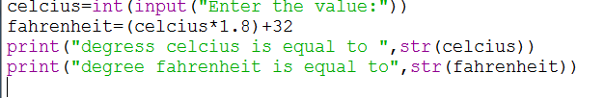

OUTPUT:

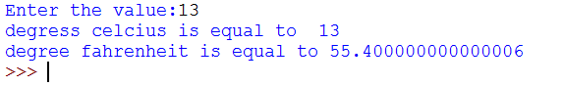

2.APPLY 5% DISCOUNT ON TOTAL COST OF n BOOKS

PROGRAM:

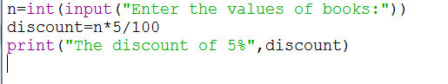

OUTPUT:

